The University of Azad Jammu and Kashmir, Muzaffarabad

Name: Alishba Zakir
Roll No: 2024-SE-02
Course: DataBase Systems
Course Code: CS-2204
Lab: 11
Submitted To: Engr. Awais Rathore
Submitted By: Alishba Zakir
Date: May , 2026

Department Of Software Engineering

Scalar Function Part :2
Numeric &Data/time Function :
Numeric functions and date/time functions are built-in tools in SQL databases used to manipulate, calculate, and format data. Numeric functions perform mathematical operations on data types like integers and decimals, while date/time functions allow you to track, alter, and extract specific parts of timestamps.
Part B:
B1: 15% discount:
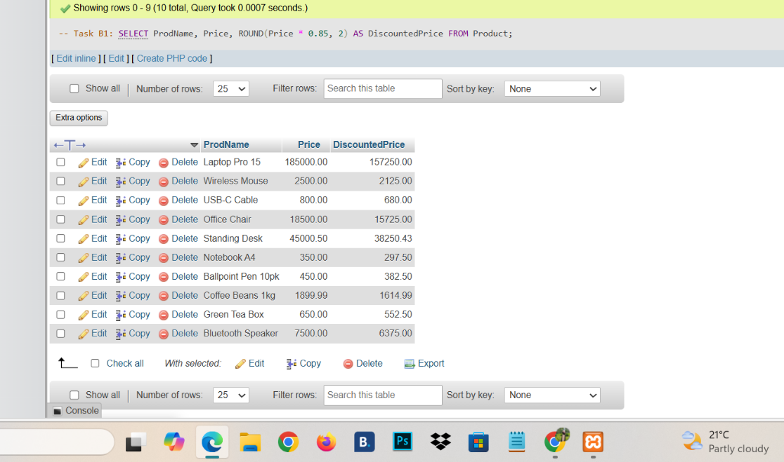
B2: 17%-Tax:
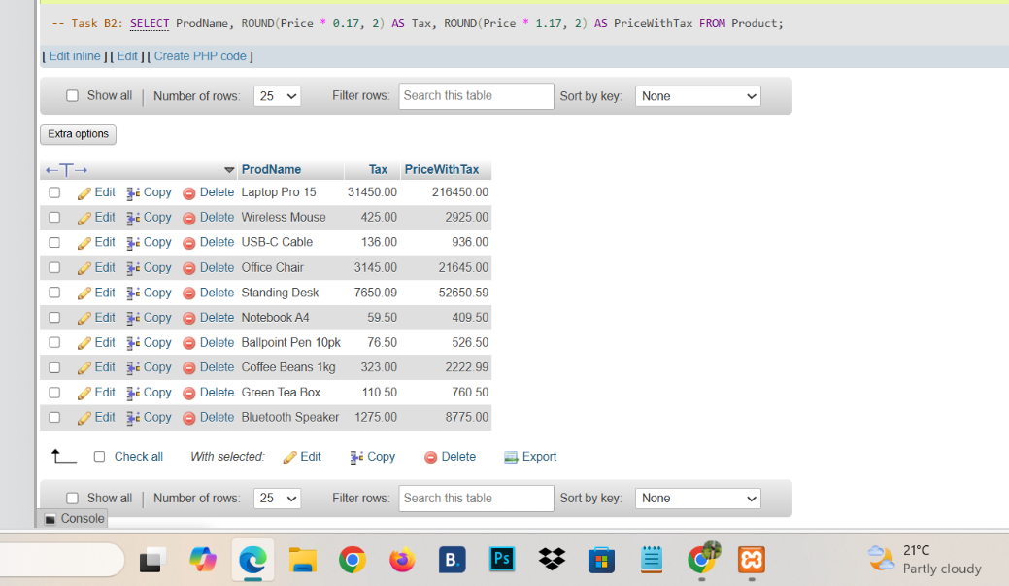
B3: Floor& Celling :
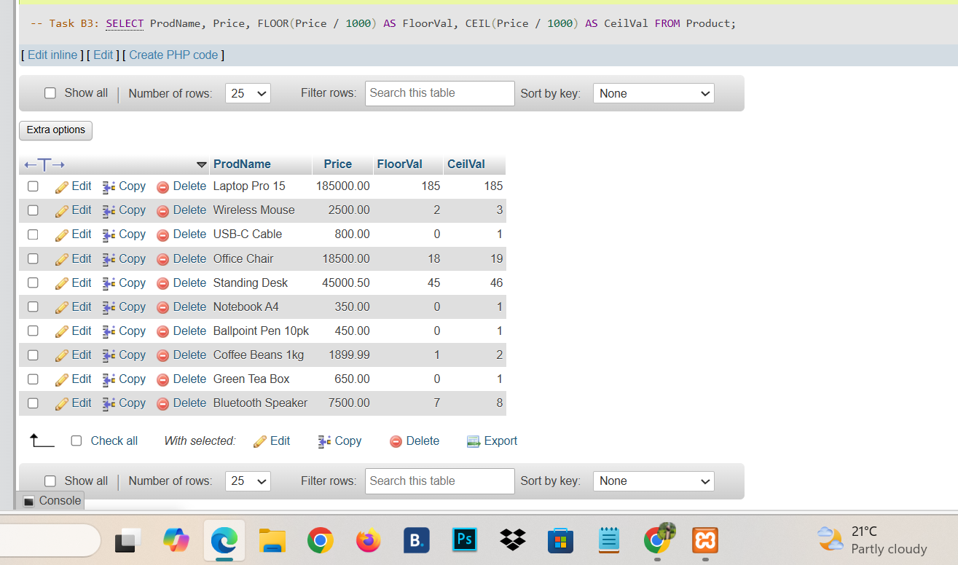
B4: Round to nearest Hundred: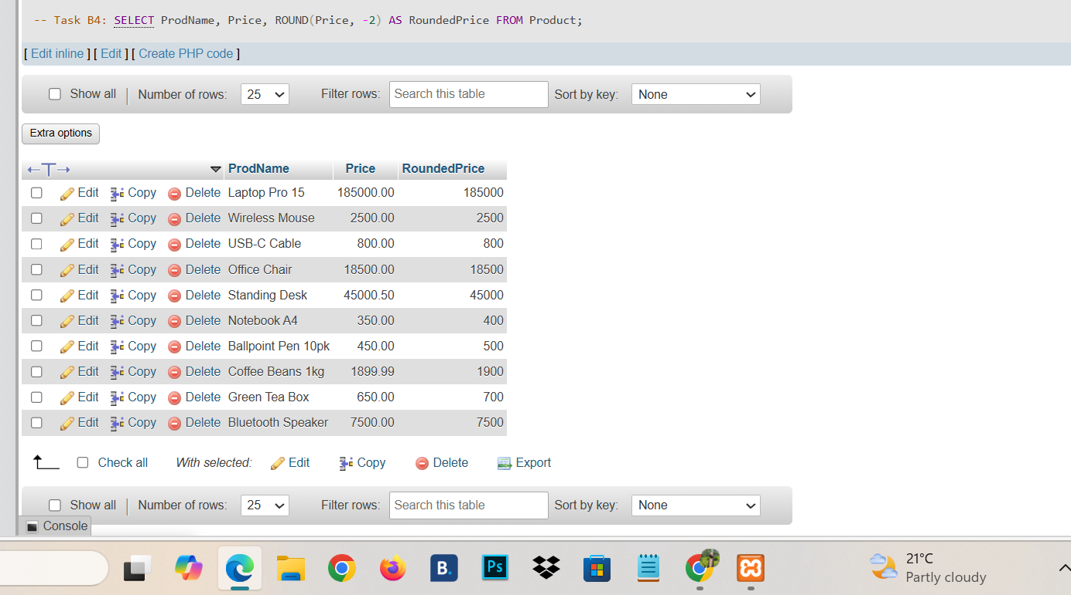
B5: Old Product IDs:
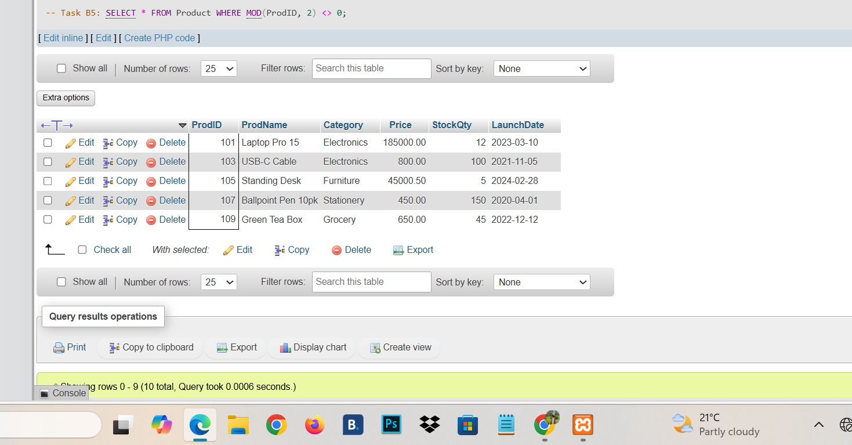
B6:Year,Month and Days : 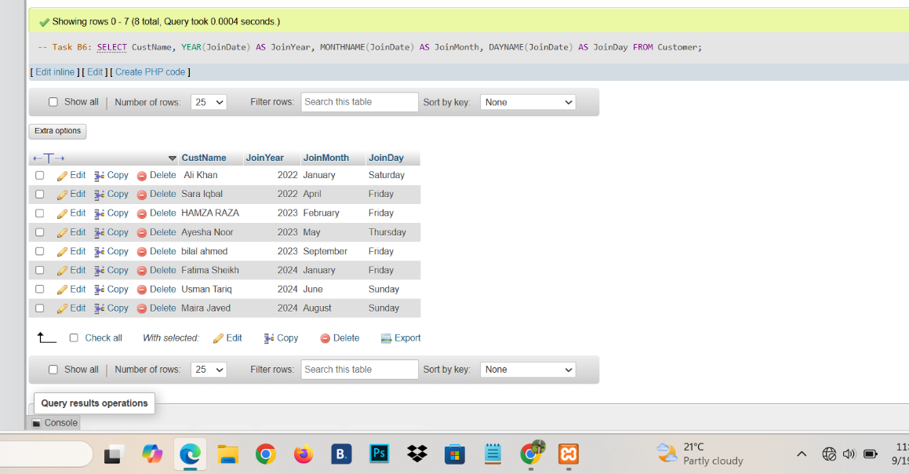
B7: DOB,DDmonth-YYYY:
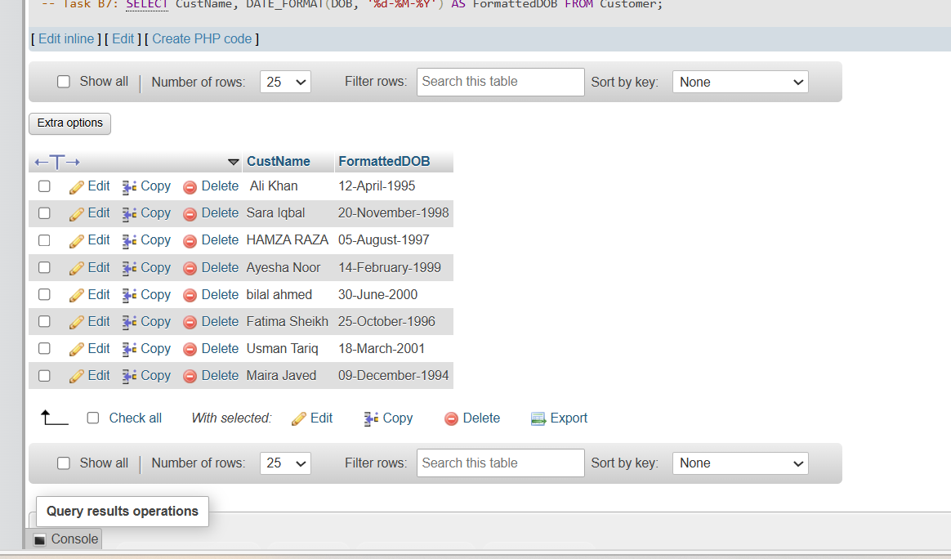
B8: Current Age : 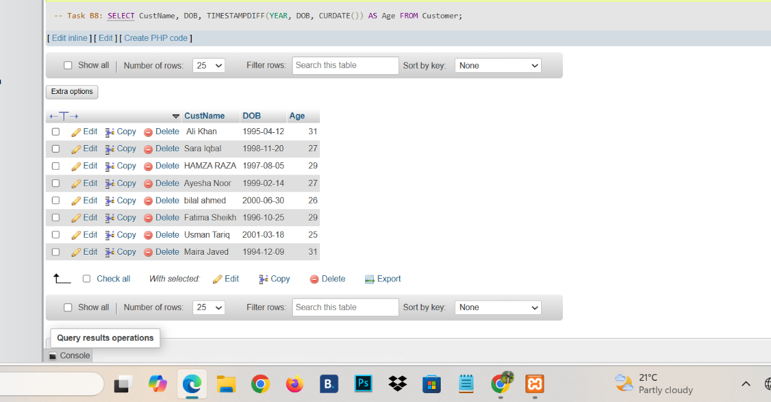
B9:Day Since Joining :
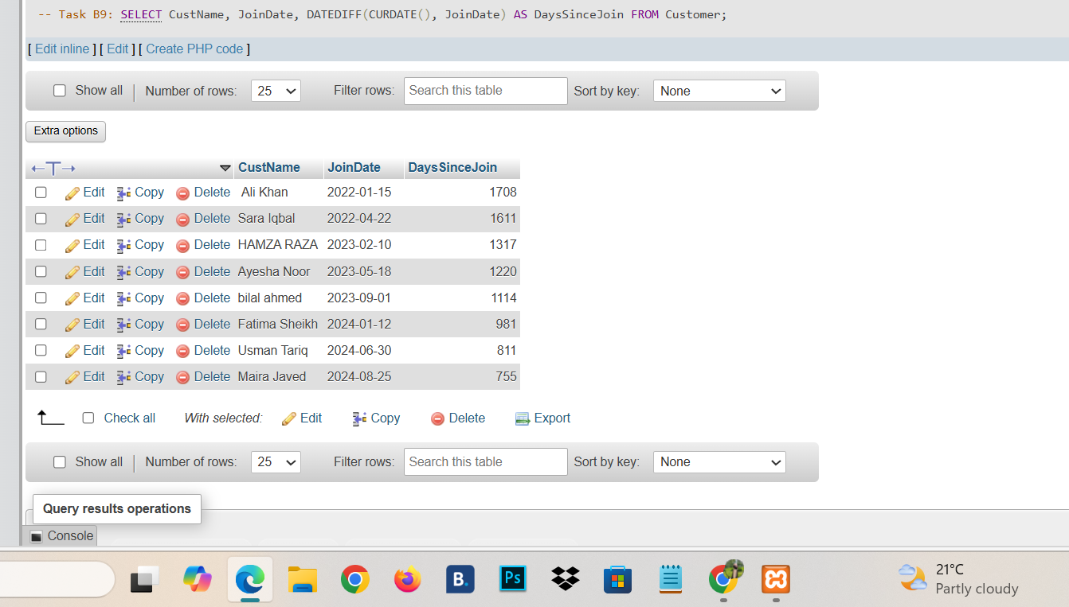
B10: Join in 2023: 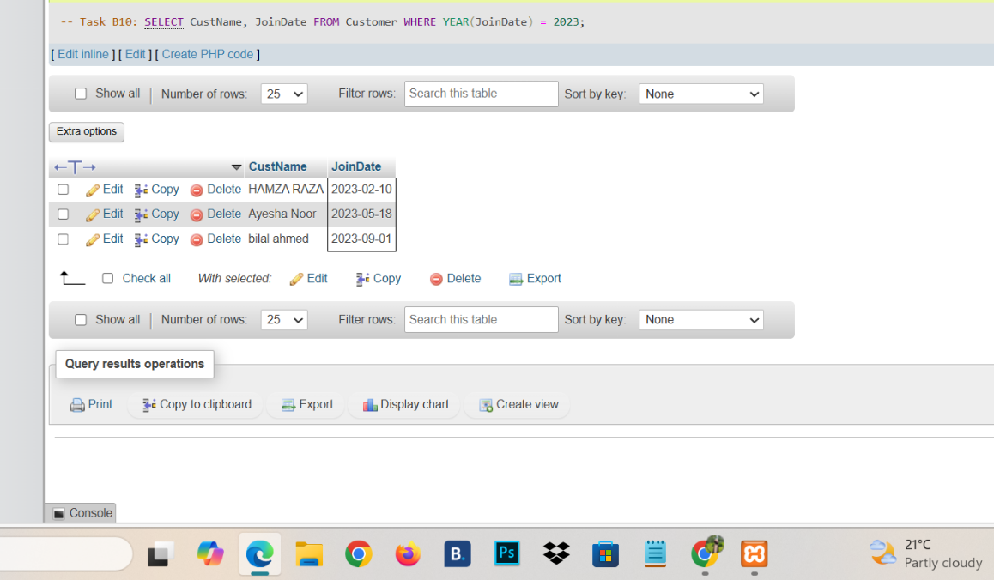
B11: Product Lunched in Oct,Nov,Dec:
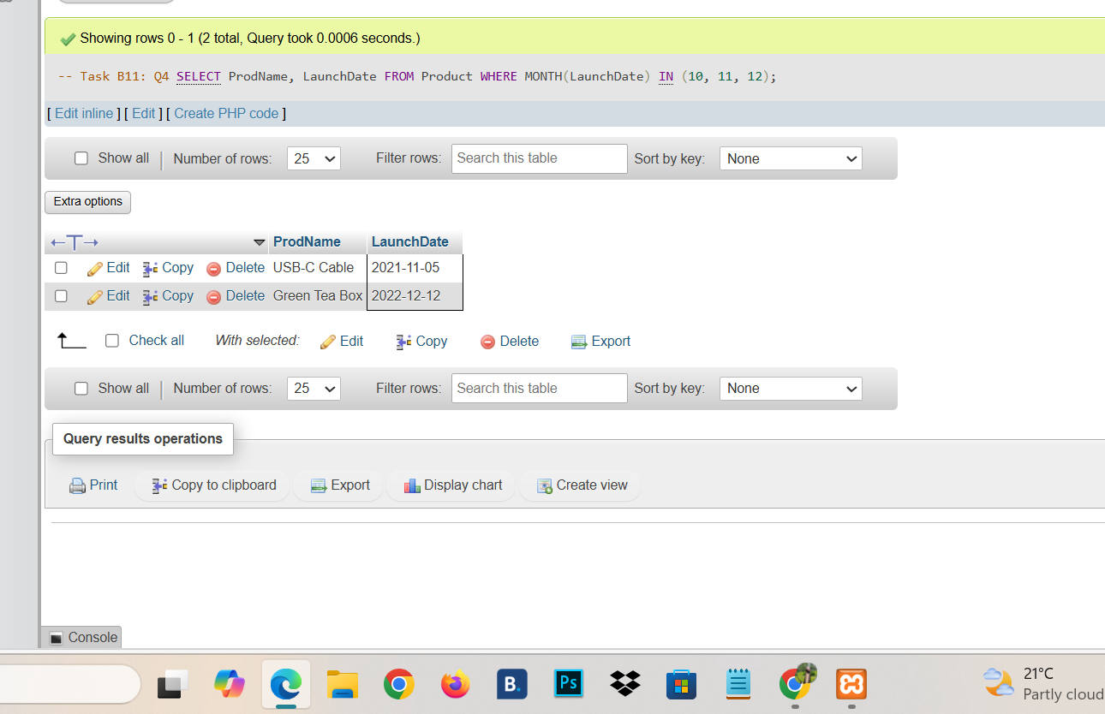
B12: Join with In last 6 month:
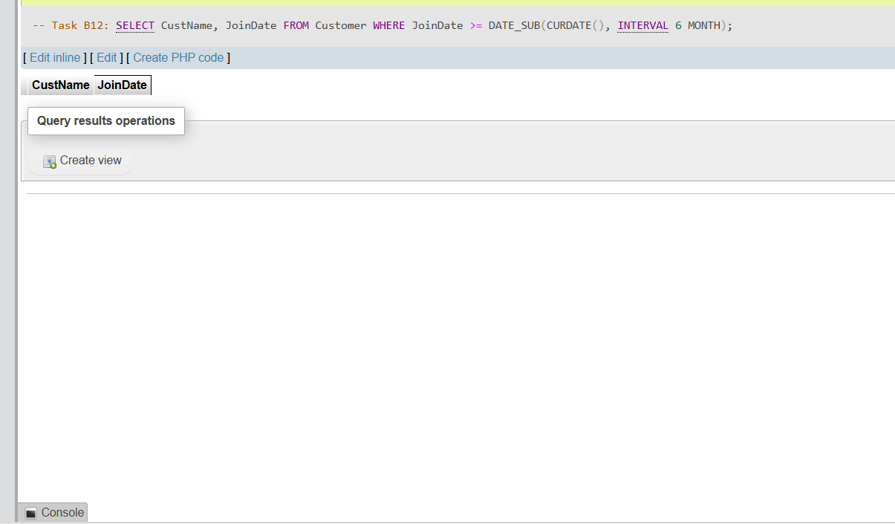
B13: Product age in days :
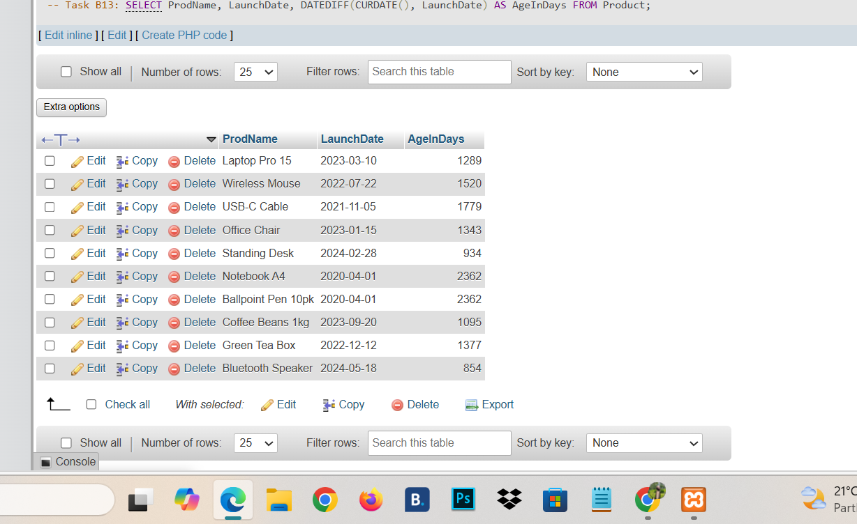
B14: Date 90 Days Later:
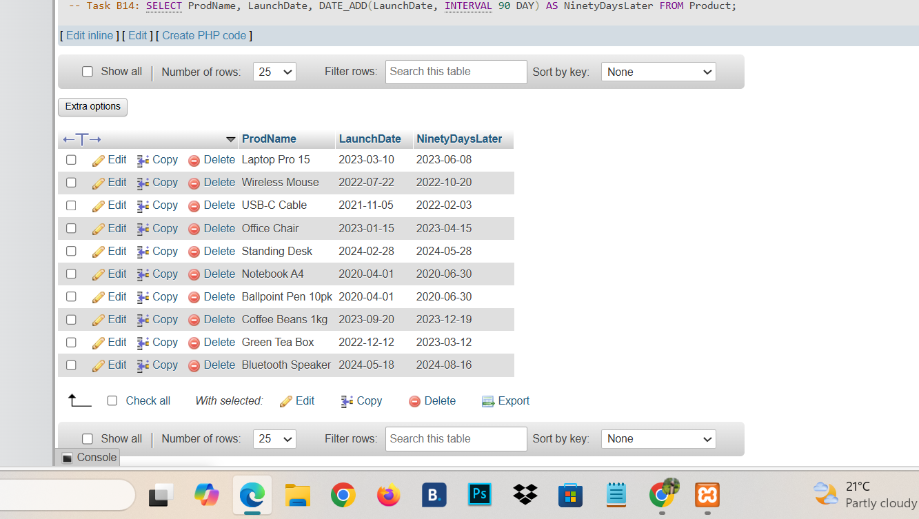
B15: Combined Challenge:
